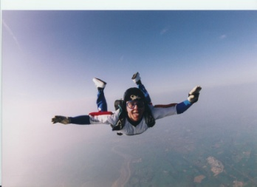**Vertical Equations –**

**Dropped Object Practice Problems**

* Earth’s gravitational acceleration for all objects is **-9.8 m/s2**.
* Use a = -9.8 for dropped problems or fired up problems on Earth.
* Falling objects will have a negative displacement.
* Their final velocities will also be negative!

**Drop Problems**

1. The Stuntman’s Freefall ride at Great Adventure - back when it existed, ☹ starts from rest, drops the passenger car in freefall, which takes 1.3 seconds. What is the final velocity of the passenger car?

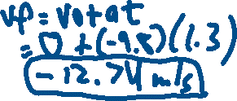

2. A watermelon falls out of a skyscraper window (from rest), it hits the ground with a final velocity of -45 m/s. How long did it take to fall?

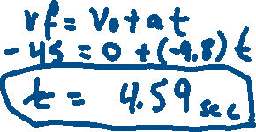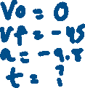

3. A construction worker drops a wrench from rest, it takes 12 seconds for the wrench to hit the ground. What was the wrench’s displacement for its fall?



4. A rock is dropped from rest, and it has a displacement of - 200 meters. How long will it take to hit the ground?



5. A child drops a plastic paratrooper figure from rest out his window 30 meters off the ground. Assuming the parachute doesn’t open (they never do), what is the figure’s final (impact) velocity?

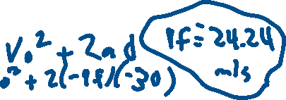

**Fired Up Problems**

6. A tennis ball is shot straight upward from a cannon with an initial upward velocity of 30 m/s. How long will it take to reach its highest point?

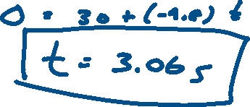

7. A rock is thrown with an initial upward velocity of 10 m/s. How high will it go at its highest point?

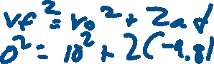

8. A missile is fired vertically and reached a maximum height of 1000m. What was its initial upward velocity?

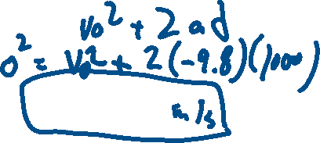

9. Joe is bored, so he throws up his cellphone into the air (don’t) with an initial upward velocity of 8 m/s,

A) How long will it take to reach its highest point?

B) How high up is the phone at its highest point?

